1. ***Guest***

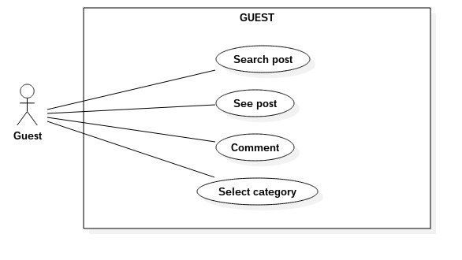

1. **Search posts**

|  |  |  |
| --- | --- | --- |
| **Author** | Tran Trong Hieu | |
| **Use Case Name** | Search posts | |
| **Actors** | Guest | |
| **Description** | Guest wants to search posts by typing to search text box. | |
| **Requirements** | Guest types texts into search text box.  Search text box is available in all guest’s accessible page. | |
| **Pre-conditions** |  | |
| **Post-conditions** | Success: Guest see a list of posts whose title contains the typed string.  Fail: “No Result” announcement or  Do nothing if search box is empty. | |
| **Basic flow** | Actor Actions:  2. Guest input post’s title into search text box.  3. click “Search” button to submit | System Responses:  1. System displays “Home” page contains:  - Posts  - Menu  - Search text box  - “Search” button  4. System use text in Search text box as post’s title to query DB.[Alternative 1]  5. System displays page which contains results in a grid. Each result contains:  - an image  - title  - category  [Alternative 2] |
| **Alternative flow** | Actor Actions: | System Responses:  [Alternative 1}  1. If Actor click “Search” button with empty Search text box, System do nothing.  [Alternative 2]  1. System display a page contains a message:  - ‘No Result Found’. |
| **Exception** |  |  |

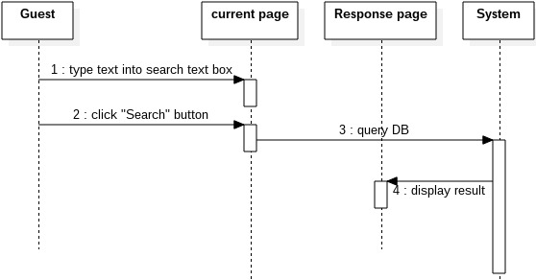

1. **See posts**
2. **View post’s detail**

|  |  |  |
| --- | --- | --- |
| **Author** | Tran Trong Hieu | |
| **Use Case Name** | View post’s detail | |
| **Actors** | Guest | |
| **Description** | Guest view contents of the post | |
| **Requirements** | There is 2 hyper link at image and post’s title.  Guest click to image or post’s title | |
| **Pre-conditions** |  | |
| **Post-conditions** | Displays contents of selected post, the related post, and the comments | |
| **Basic flow** | Actor Actions:  2. Guest click the hyper links of post. | System Responses:  1. System displays list of posts. Each post have:  - an image (hyper link)  - title (hyper link)  - modified Date  3. System take post ID from the clicked link.  4. System queries DB to take post location.  5. System reads the post’s contents into the response page.  6. System displays response page. |
| **Alternative flow** |  |  |
| **Exception** |  |  |

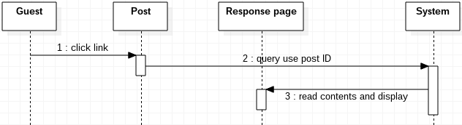

1. **View same category posts**

|  |  |  |
| --- | --- | --- |
| **Author** | Tran Trong Hieu | |
| **Use Case Name** | View same category posts | |
| **Actors** | Guest | |
| **Description** | At the right of the current viewed post will display some posts having same category with the current post. | |
| **Requirements** | Category of the current viewed post | |
| **Pre-conditions** | Guest click to see contents of a post. | |
| **Post-conditions** | List of posts having same category of the current post. | |
| **Basic flow** | Actor Actions:  2. Guest click the hyper links of post. | System Responses:  1. System displays list of posts. Each post have:  - an image (hyper link)  - title (hyper link)  - modified Date  3. System take post ID from the clicked link.  4. System queries DB to take post’s category.  5. System queries DB take random 5 post.  6. System return result and display response page. |
| **Alternative flow** |  |  |
| **Exception** |  |  |

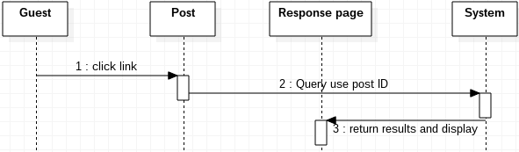

1. **View post’s comments**

|  |  |  |
| --- | --- | --- |
| **Author** | Tran Trong Hieu | |
| **Use Case Name** | View comments of post | |
| **Actors** | Guest | |
| **Description** | Guest see comments below the post. | |
| **Requirements** |  | |
| **Pre-conditions** | Guest click to see contents of a post. | |
| **Post-conditions** | Display all comments belong to the post | |
| **Basic flow** | Actor Actions:  2. Guest click the hyper links of post. | System Responses:  1. System displays list of posts. Each post have:  - an image (hyper link)  - title (hyper link)  - modified Date  3. System take post ID from the clicked link.  4. System queries DB to take all comments and guest information.  5. System return list of comments. Each comments will have:  - Name of the guest comment  - The contents  - Comment time  6. System display response page. |
| **Alternative flow** |  |  |
| **Exception** |  |  |

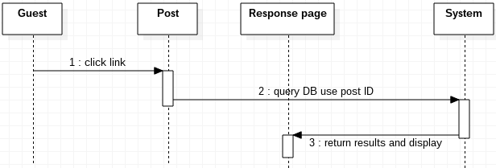

1. **Select Categories**

|  |  |  |
| --- | --- | --- |
| **Author** | Tran Trong Hieu | |
| **Use Case Name** | Select Categories | |
| **Actors** | Guest | |
| **Description** | Guest click categories in the menu or the link | |
| **Requirements** |  | |
| **Pre-conditions** |  | |
| **Post-conditions** | Display list of posts having the clicked category. | |
| **Basic flow** | Actor Actions:  1. Guest click the name of category, which contains a hyper link. | System Responses:  2. System take the category name and query posts.  3. System return results and display response page. |
| **Alternative flow** |  |  |
| **Exception** |  |  |

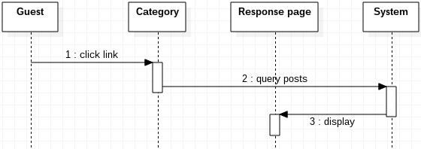

1. ***Administrator***

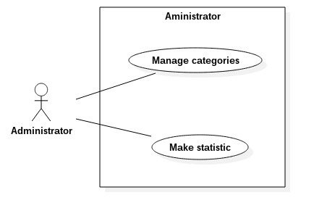

1. **Manage categories**
2. **Add new categories**

|  |  |  |
| --- | --- | --- |
| **Author** | Tran Trong Hieu | |
| **Use Case Name** | Add Category | |
| **Actors** | Administrator | |
| **Description** | Administrator add new categories. | |
| **Requirements** | Administrator input category’s information | |
| **Pre-conditions** | Administrator has logged in | |
| **Post-conditions** | Success: New category added and appear “Add successfully” announcement  Fail: appear “Add Fail” announcement. | |
| **Basic flow** | Actor Actions:  1. Actor choose “Add category” option in menu of “Administrator” page.  3. Actor inputs information and click “submit” button. | System Responses:  2. System displays a page with form contains:  - ‘Name’: a text field for category’s name  - ‘Parent-category’: a combo box contains name of all active category.  - A submit button.  4. System check information [Exception 1]  5. System reload current page with an announcement “Add Successfully” at the top of page. |
| **Alternative flow** |  |  |
| **Exception** | Actor actions:  [Exception 1]  1. Actor left ‘Name’ field empty  2. ‘Name’ is existed. | System Response:  System display message:  - ‘Category name is required’  - ‘Category name is existed’ |

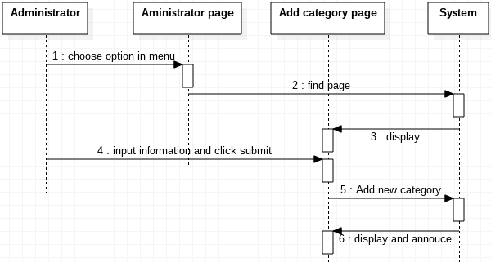

1. **Modify category’s field**

|  |  |  |
| --- | --- | --- |
| **Author** | Tran Trong Hieu | |
| **Use Case Name** | Modify Category | |
| **Actors** | Administrator | |
| **Description** | Administrator want to change attributes of category | |
| **Requirements** | Administrator input informations. | |
| **Pre-conditions** | Administrator need login first. | |
| **Post-conditions** | Success: Update the current page  Fail: Reload page without any change | |
| **Basic flow** | Actor Actions:  1. Actor choose “Modify category” option in menu of “Administrator” page.  3. Actor inputs information and click “submit” button. | System Responses:  2. System displays list of all categories in form of a table contains columns:  - ‘No’: row number  - ‘Name’: a text field for category’s name  - ‘Parent-category’: a combo box contains name of all active category.  - “Sub-category’: a combo box to change it’s sub-category  - ‘Enable’: a check box  - ‘Update’: a submit button.  4. System check information [Exception 1]  5. System reload current page with updated table |
| **Alternative flow** |  |  |
| **Exception** | Actor actions:  [Exception 1]  1. Actor left ‘Name’ field empty  2. ‘Name’ is existed.  3. Conflict between parent-category and sub-category. | System Response:  System reload the current page without any change. |

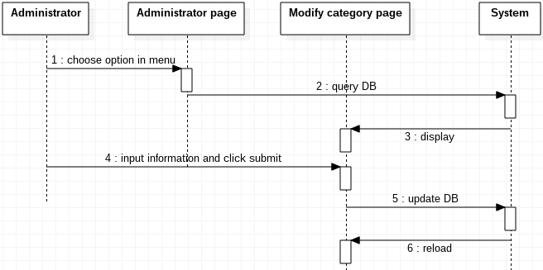

1. **Make statistics**
2. **View total post in amount of time**

|  |  |  |
| --- | --- | --- |
| **Author** | Tran Trong Hieu | |
| **Use Case Name** | View total post | |
| **Actors** | Administrator | |
| **Description** | Administrator the quantity post in two specific time in 3 groups:  - total of accepted post  - total of rejected post  - total of pending post | |
| **Requirements** | - The begin time  - The end time | |
| **Pre-conditions** | Administrator must login | |
| **Post-conditions** | Success: Administrator see the total of post in 3 group.  Fail: Display message “No Result” | |
| **Basic flow** | Actor Actions:  1. Actor choose “View total post” option in menu of “Administrator” page.  3. Actor inputs begin date, end date and click “submit” button. | System Responses:  2. System display page with:  - ‘Begin time’: a text box  - ‘End time’: a text box  - a submit button  4. System check information [Exception 1]  5. System displays 3 groups have the total post:  - total of accepted post  - total of rejected post  - total of pending post  [Alternative 1] |
| **Alternative flow** | Actor actions: | System Response:  [Alternative 1]  1. System have no result between specific times and return a message “No result” |
| **Exception** | Actor actions:  [Exception 1]  1. Actor left ‘Begin time’ field empty  2. Actor left ‘End time’ field empty  3. Actor enter wrong format of date  4. Actor enter not valid date:  - not valid day in month  - not valid month  - not valid year | System Response:  1. Display message ‘begin time required’.  2. display message ‘end time required’  3. display message ‘wrong format’  4. display message ‘date not valid’ |

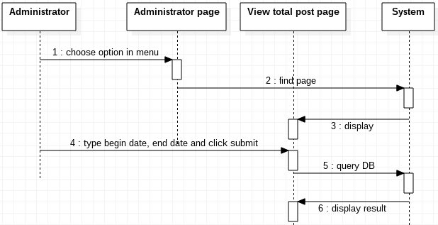

1. **View list of post ordered by descending total numerous views**

|  |  |  |
| --- | --- | --- |
| **Author** | Tran Trong Hieu | |
| **Use Case Name** | See list of post by view number | |
| **Actors** | Administrator | |
| **Description** | Administrator see a list of posts in order of descending total views in 2 specific times. | |
| **Requirements** |  | |
| **Pre-conditions** |  | |
| **Post-conditions** | Administrator see a list of posts in order of descending total views | |
| **Basic flow** | Actor Actions:  1. Actor choose “View post by view number” option in menu of “Administrator” page.  3. Actor inputs begin date, end date and click “submit” button. | System Responses:  2. System display page with:  - ‘Begin time’: a text box  - ‘End time’: a text box  - a submit button  4. System check information [Exception 1]  5. System displays result in table has:  - entry number  - title  - Category  - View number  [Alternative 1] |
| **Alternative flow** | Actor actions: | System Response:  [Alternative 1]  1. System have no result between specific times and return a message “No result” |
| **Exception** | Actor actions:  [Exception 1]  1. Actor left ‘Begin time’ field empty  2. Actor left ‘End time’ field empty  3. Actor enter wrong format of date  4. Actor enter not valid date:  - not valid day in month  - not valid month  - not valid year | System Response:  1. Display message ‘begin time required’.  2. display message ‘end time required’  3. display message ‘wrong format’  4. display message ‘date not valid’ |

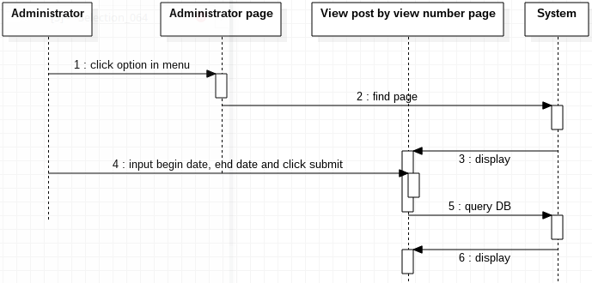

1. ***Collaborator***

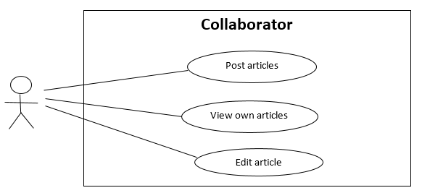

1. **Post article**

|  |  |  |
| --- | --- | --- |
| **Author** | Vo Gia Vu | |
| **Use Case Name** | Post articles | |
| **Actors** | Collaborator | |
| **Description** | Collaborator wants to post articles to system for pending | |
| **Requirements** | Collaborator provide articles information | |
| **Pre-conditions** | Actor has logged in as Collaborator | |
| **Post-conditions** | Success: Collaborator creates an article and sends to system in pending status  Fail: Refill information | |
| **Basic flow** | Actor Actions:  1. Actor click ‘Upload’ button on Home page menu.  3. Actor input article’s information, select and ‘Subcategory’ combo box and click ‘Submit’ button. [Alternative 1] | System Responses:  2. System redirects to ‘Upload’ page and display Article form with following control:  -‘Title’ text field  -‘Content’ text area  -‘Subcategory’ combo box  -‘Submit’ button  4. System checks the information [Exception 1] |
| **Alternative flow** | Actor Actions:  [Alternative 1]  1. Actor click ‘Home’ button | System Responses:  2. System returns to Home page. |
| **Exception** | Actor Actions:  [Exception 1]  1. Actor left ‘Title’ text field blank.  2. Title has already exists  3. Actor left ‘Content’ text area blank. | System Responses:  System display message to Actor:  - ‘Title cannot be blank.’  - ‘This Title has already exist.’  - ‘Content cannot be blank.’ |

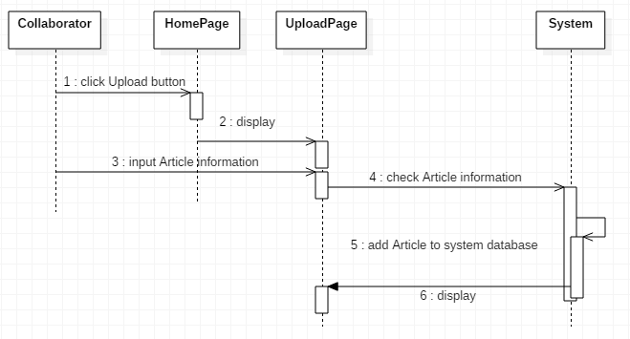

1. **View own article**

|  |  |  |
| --- | --- | --- |
| **Author** | Vo Gia Vu | |
| **Use Case Name** | View own articles | |
| **Actors** | Collaborator | |
| **Description** | Collaborator wants to view their own article including pending, accepted, rejected articles | |
| **Requirements** |  | |
| **Pre-conditions** | Actor has logged in as Collaborator | |
| **Post-conditions** | Success: Chosen article shows up  Fail: Error Page shown | |
| **Basic flow** | Actor Actions:  1. Actor click ‘Articles’ button on Home page menu.  3. Actor click on the ‘Title’ hyperlink or ‘Theme image’ hyperlink of chosen article to view [Alternative 1] [Alternative 2] | System Responses:  2. System redirects to ‘Article Management’ page and display article list in grid layout. Articles grouped by status and displayed in order latest to oldest with these information:  - ’Theme image’ hyperlink  - ’Title’ hyperlink  - ‘Date time’ label  - ‘Edit’ button  4. System redirects to ‘View Details’ page and display article in a frame with information:  - Category  - Subcategory  - Date time  - Title  - Content  - Author |
| **Alternative flow** | Actor Actions:  [Alternative 1]  1. Actor click on hyperlink as ‘Reason’ field at rejected article  [Alternative 2]  1. Actor click ‘Home’ button | System Responses:  2. System redirects to ‘Reason’ page and display reason in a frame  2. System returns to Home page. |
| **Exception** |  |  |

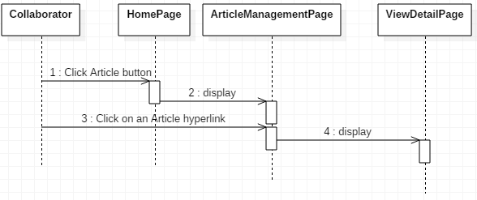

1. **Edit own articles**

|  |  |  |  |
| --- | --- | --- | --- |
| **Author** | Vo Gia Vu | |  |
| **Use Case Name** | Edit own articles | |  |
| **Actors** | Collaborator | |  |
| **Description** | Collaborator wants to edit own articles | |  |
| **Requirements** | Actor provide Article information | |  |
| **Pre-conditions** | Actor has logged in as Collaborator or Employee or Manager or Administrator | |  |
| **Post-conditions** | Success: Article is modified and updated into database  Fail: Refill information | |  |
| **Basic flow** | Actor Actions:  1. Actor click ‘Edit’ button in Article’s information on ‘Article Management’ page.  3. Actor modify information and click ‘Submit’ button [Alternative 1][Alternative 2] | System Responses:  2. System redirects to ‘Edit’ page and display article in a frame with information:  - ‘Subcategory’ combo box  - ‘Title’ text box  - ‘Content’ text area  - ‘Submit’ button  - ‘Cancel’ button  4. System checks the information and redirects to ‘View Details’ page and display article  [Exception 1] |  |
| **Alternative flow** | Actor Actions:  [Alternative 1]  1. Actor click ‘Cancel’ button  [Alternative 2]  1. Actor click ‘Home’ button | System Responses:  2. System redirects ‘View Details’ page and display article  2. System returns to Home page. |  |
| **Exception** | Actor Actions:  [Exception 1]  1. Actor left ‘Title’ text field blank.  2. Title has already exists  3. Actor left ‘Content’ text area blank. | System Responses:  - ‘Title cannot be blank.’  - ‘This Title has already exist.’  - ‘Content cannot be blank. |  |

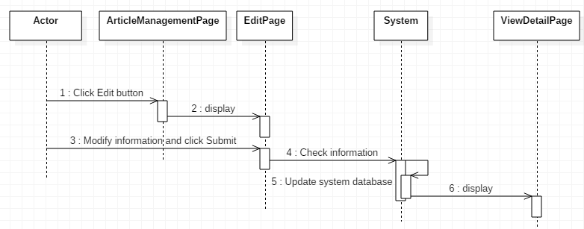

1. ***Collaborator – Employee – Manager – Administrator***

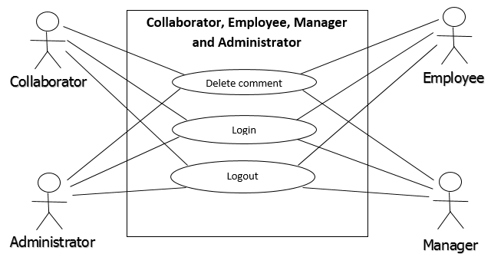

1. **Delete comment**

|  |  |  |
| --- | --- | --- |
| **Author** | Vo Gia Vu | |
| **Use Case Name** | Delete comment | |
| **Actors** | Collaborator or Employee or Manager or Administrator | |
| **Description** | Collaborator or Employee or Manager or Administrator wants to delete comments on accepted article | |
| **Requirements** |  | |
| **Pre-conditions** | Actor has logged in as Collaborator or Employee or Manager or Administrator | |
| **Post-conditions** | Success: Comment must be changed status in system database  Fail: Error Page shown | |
| **Basic flow** | Actor Actions:  1. Actor click ‘Delete’ button beside of comment below article in ‘View Details’ page  3. Actor click ‘Yes’ button [Alternative 1] | System Responses:  2. System display a confirm dialog with following control:  - ‘Yes’ button  - ‘No’ button  4. System change comment’s status in database into ‘Disable’ |
| **Alternative flow** | Actor Actions:  [Alternative 2]  1. Actor click ‘No’ button | System Responses:  2. System close confirm dialog |
| **Exception** |  |  |

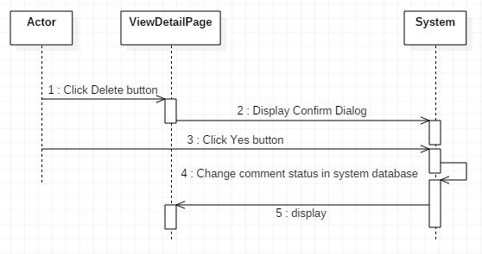

1. **Log in**

|  |  |  |
| --- | --- | --- |
| **Author** | Vo Gia Vu | |
| **Use Case Name** | Login | |
| **Actors** | Collaborator or Employee or Manager or Administrator | |
| **Description** | Collaborator or Employee or Manager or Administrator wants to login as Collaborator or Employee or Manager or Administrator | |
| **Requirements** | Actor provides username and password | |
| **Pre-conditions** |  | |
| **Post-conditions** | Success: User logged in to website  Fail: Refill information | |
| **Basic flow** | Actor Actions:  1. Actor go to specific ‘Login’ page for staff to login  3. Actor inputs ‘User Name’ and ‘Password’, then click the ‘Login’ button [Alternative 1] | System Responses:  2. System redirects to ‘Login’ page and displays Login form with following control:  - ‘User Name’ text field  - ‘Password’ text field  - ‘Login’ button  - ‘Reset’ button  4. System checks the information [Exception 1]  5. System redirects to ‘Home’ page |
| **Alternative flow** | Actor Actions:  [Alternative 1]  1. Actor click ‘Reset’ button  [Alternative 2]  1. Actor click ‘OK’ button to close message box, input ‘User Name’ and ‘Password’, then click ‘Login’ button | System Responses:  2. System clears information in ‘User Name’ and ‘Password’ text field  2. System checks the information [Exception 1] |
| **Exception** | Actor Actions:  [Exception 1]  1. Actor input invalid username and password | 2. System redirects to ‘Login’ page with following controls:  - ‘User Name’ text field  - ‘Password’ text field  - ‘Login’ button  - ‘Reset’ button  3. System show a message box: “Invalid Username or Password”. [Alternative 2] |

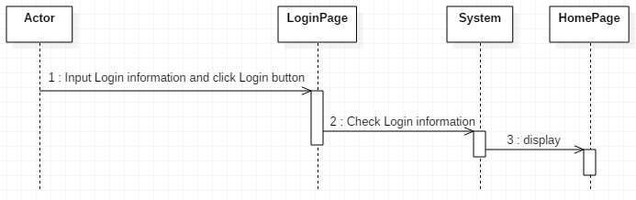

1. **Log out**

|  |  |  |
| --- | --- | --- |
| **Author** | Vo Gia Vu | |
| **Use Case Name** | Logout | |
| **Actors** | Collaborator or Employee or Manager or Administrator | |
| **Description** | Collaborator or Employee or Manager or Administrator wants to log out of System | |
| **Requirements** |  | |
| **Pre-conditions** | Actor has logged in | |
| **Post-conditions** | Success: Actor logged out | |
| **Basic flow** | Actor Actions:  1. Actor click ‘Log out’ button on the menu  3. Actor click ‘Yes’ button [Alternative 1] | System Responses:  2. System shows confirm dialog with following control:  - ‘Yes’ button  - ‘No’ button  4. System removes session, then redirects to ‘Login’ page |
| **Alternative flow** | Actor Actions:  [Alternative 1]  1. Actor click ‘No’ button | System Responses:  2. System closes confirm dialog |
| **Exception** |  |  |

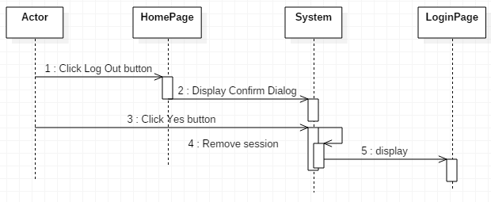

1. ***Employee***

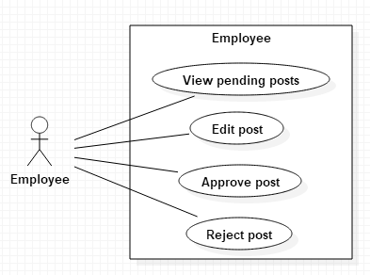

1. **View pending posts**

|  |  |  |
| --- | --- | --- |
| **Author** | Nguyen Viet Hung | |
| **Use Case Name** | View pending posts | |
| **Actors** | Employee, Manager | |
| **Description** | Actor can view pending posts of collaborator in the specific subcategories he/she manages. | |
| **Requirements** | System provide page with grid of pending posts by collaborator with Title, author’s name, time and first image. | |
| **Pre-conditions** | Actor must log in as Employee or Manager. | |
| **Post-conditions** | Success: Display a new page with the details of the post. | |
| **Basic flow** | Actor Actions:  1. Actor clicks ‘Review posts’ in the Menu bar.  3. Actor clicks on one of the post in grid. [Alternative 1] | System Responses:  2. System redirects to Review Posts page. The Review Posts page have a grid of pending posts, each item in grid present an article:  - Title.  - Subcategory  - Author’s name.  - Time.  - First image in the post.  4. System redirects to the Details Post page that display the article:  - Title.  - Subcategory.  - Author’s name.  - Time.  - Content.  - ‘Edit’ button.  - ‘Approve’ button.  - ‘Reject’ button. |
| **Alternative flow** | Actor Actions:  [Alternative 1]  1. Actor click ‘Home’ button | System Responses:  2. System returns to Home page. |
| **Exception** |  |  |

1. **Edit posts**

|  |  |  |
| --- | --- | --- |
| **Author** | Nguyen Viet Hung | |
| **Use Case Name** | Edit posts | |
| **Actors** | Employee, Manager | |
| **Description** | Actor can edit pending post of collaborator before approving it. | |
| **Requirements** | System provide Details Post page with details of pending post with Title, subcategory, author’s name, time and content. | |
| **Pre-conditions** | Actor must log in as Employee or Manager. | |
| **Post-conditions** | Success: Edit post and approve it.  Fail: Show Error Page. | |
| **Basic flow** | Actor Actions:  1. Actor clicks ‘Edit’ button in the article.  3. Actor edits title, subcategory and content if necessary and click ‘Approve’ button. [Alternative 1] [Alternative 2] | System Responses:  2. System redirects to Edit Post page:  - Title: textfield.  - Subcategory: combobox.  - Content: textarea.  - ‘Approve’ button.  - ‘Cancel’ button.  4. System checks value in input fields.  [Exception 1]  5. System updates post in server:  - Title  - Subcategory  - Content  - Status: ‘pending for manager’ (employee’s action) or ‘rejected’ (manager’s action)  6. System announces successful and redirect to Review Posts page. |
| **Alternative flow** | Actor Actions:  [Alternative 1]  1. Actor clicks ‘Cancel’ button  [Alternative 2]  3. Actor clicks ‘Home’ button | System Responses:  2. System returns to Details Post page.  4. System returns to Home page. |
| **Exception** | Actor Actions:  [Exception 1]  1. Actor deletes all text in ‘title’ textfield.  2. Actor deletes all content in ‘content’ area. | System Responses:  System displays message to Actor :  - ‘Title cannot be blank’.  - ‘Content cannot be blank’. |

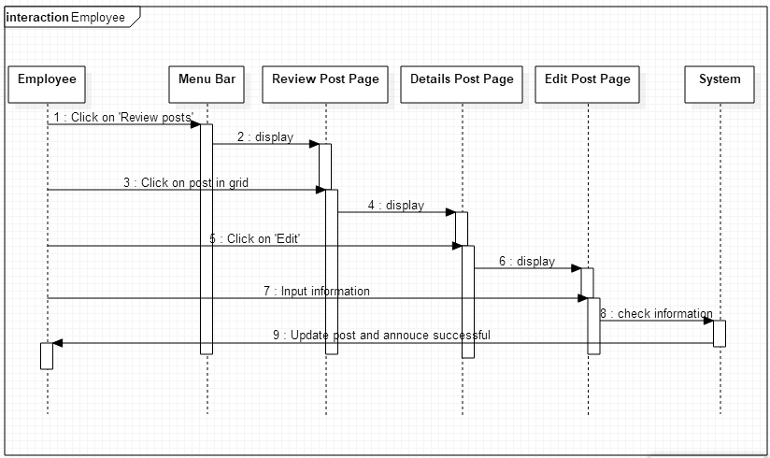

1. **Approve posts**

|  |  |  |
| --- | --- | --- |
| **Author** | Nguyen Viet Hung | |
| **Use Case Name** | Approve posts | |
| **Actors** | Employee, Manager | |
| **Description** | Actor can approve post. With employee, after approving, the post will be passed to manager, with manager, approved post will be showed on the website. | |
| **Requirements** | System provide Details Post page with details of pending post with Title, subcategory, author’s name, time and content. | |
| **Pre-conditions** | Actor must log in as Employee or Manager. | |
| **Post-conditions** | Success: Approve post.  Fail: Show Error Page. | |
| **Basic flow** | Actor Actions:  1. Actor clicks ‘Approve’ button in the article.  [Alternative 1] | System Responses:  2. System updates post in server:  - Status: ‘pending for manager’ (employee’s action) or ‘accepted’ (manager’s action)  3. System announces successful and redirect to Review Posts page. |
| **Alternative flow** | Actor Actions:  [Alternative 1]  1. Actor clicks ‘Home’ button | System Responses:  2. System returns to Home page. |
| **Exception** |  |  |

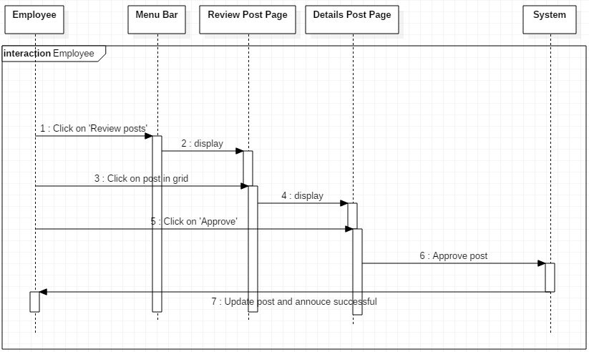

1. **Reject posts**

|  |  |  |
| --- | --- | --- |
| **Author** | Nguyen Viet Hung | |
| **Use Case Name** | Reject posts | |
| **Actors** | Employee, Manager | |
| **Description** | Actor can reject post. A reason for rejecting the post will be required. | |
| **Requirements** | System provide Details Post page with details of pending post with Title, subcategory, author’s name, time and content. | |
| **Pre-conditions** | Actor must log in as Employee or Manager. | |
| **Post-conditions** | Success: Reject post.  Fail: Show Error Page. | |
| **Basic flow** | Actor Actions:  1. Actor clicks ‘Reject’ button in the article.  [Alternative 1]  3. Actor inputs the reason and clicks ‘Reject’ button in the modal.  [Alternative 2] | System Responses:  2. System displays a modal to ask the reason for rejecting the post. (textarea)  4. System checks value in input fields.  [Exception 1]  5. System updates post in server:  - Status: ‘rejected’.  6. System annouces successful and redirect to Review Posts page. |
| **Alternative flow** | Actor Actions:  [Alternative 1]  1. Actor clicks ‘Home’ button  [Alternative 2]  3. Actor clicks ‘Cancel’ button | System Responses:  2. System returns to Home page.  4. System closes the modal. |
| **Exception** | Actor Actions:  [Exception 1]  1. Actor leaves the textfield blank. | System Responses:  System displays message to Actor :  - ‘Reason is required’. |

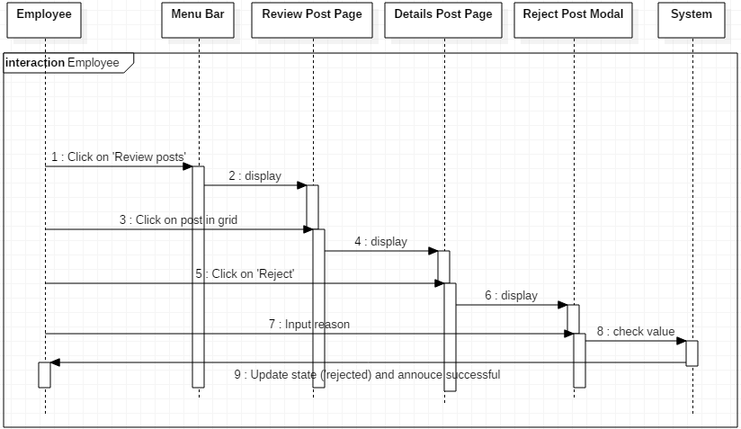

1. ***Manager***

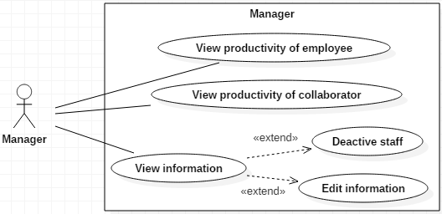

1. **View productivity of collaborator**

|  |  |  |
| --- | --- | --- |
| **Author** | Nguyen Viet Hung | |
| **Use Case Name** | View productivity of collaborator | |
| **Actors** | Manager, Administrator | |
| **Description** | Actor can view the productivity of all collaborators. | |
| **Requirements** | System provide page with grid of collaborators with some statistics:   * Number of accepted posts * Number of rejected posts * Number of pending posts * Average time for every new posts * Average views and comments | |
| **Pre-conditions** | Actor must log in as Manager or Administrator. | |
| **Post-conditions** | Success: Display a new page with the grid of collaborators. | |
| **Basic flow** | Actor Actions:  1. Actor clicks ‘Manage collaborators’ in the Menu bar. | System Responses:  2. System redirects to Manage Collaborator page. The Manage Collaborator page have a grid of collaborators with:  - Name.  - Username.  - Number of accepted posts  - Number of rejected posts  - Number of pending posts  - Average time for every new posts  - Average views and comments |
| **Alternative flow** |  |  |
| **Exception** |  |  |

1. **View productivity of employee**

|  |  |  |
| --- | --- | --- |
| **Author** | Nguyen Viet Hung | |
| **Use Case Name** | View productivity of employee | |
| **Actors** | Manager, Administrator | |
| **Description** | Actor can view the productivity of all employees. | |
| **Requirements** | System provide page with grid of employees with some statistics:   * Number of posts accepted by employee. * Number of posts rejected by employee. * Average time for checking new posts. * Average views and comments of posted approved by employee. | |
| **Pre-conditions** | Actor must log in as Manager or Administrator. | |
| **Post-conditions** | Success: Display a new page with the grid of employees. | |
| **Basic flow** | Actor Actions:  1. Actor clicks ‘Manage employees’ in the Menu bar. | System Responses:  2. System redirects to Manage Employee page. The Manage Employee page have a grid of collaborators with:  - Name - hyperlink  - Username - hyperlink  - Number of posts accepted by employee.  - Number of posts rejected by employee.  - Average time for checking new posts.  - Average views and comments of posted approved by employee. |
| **Alternative flow** |  |  |
| **Exception** |  |  |

1. **View information and deactivated staff**

|  |  |  |
| --- | --- | --- |
| **Author** | Nguyen Viet Hung | |
| **Use Case Name** | View information and deactivated staff | |
| **Actors** | Manager, Administrator | |
| **Description** | Actor can view information of all employees and collaborators then deactivate them. | |
| **Requirements** | System must provide Manage Employee page and Manage Collaborator page with grid of staffs. | |
| **Pre-conditions** | Actor must log in as Manager or Administrator. | |
| **Post-conditions** | Success: Deactivate staff.  Fail: Show Error Page. | |
| **Basic flow** | Actor Actions:  1. Actor clicks on name or username of staff on the grid of Manage Employee page or Manage Collaborator page.  [Alternative 1]  3. Actor clicks on ‘Deactivate’ button.  [Alternative 1]  5. Actor clicks on ‘OK’ button.  [Alternative 2] | System Responses:  2. System redirects to Information Staff page:  - First name  - Last name  - Username  - Phone number  - Email  - Date of birth  - Address  - Gender  - Working categories  - Role  - ‘Deactivate’ button  4. System shows a confirm modal with ‘OK’ button and ‘Cancel’ button.  6. System updates that staff as deactivated and show successful message. |
| **Alternative flow** | Actor actions:  [Alternative 1]  1. Actor clicks ‘Home’ button  [Alternative 2]  3. Actor clicks ‘Cancel’ button | System Responses:  2. System returns to Home page.  4. System closes modal. |
| **Exception** |  |  |

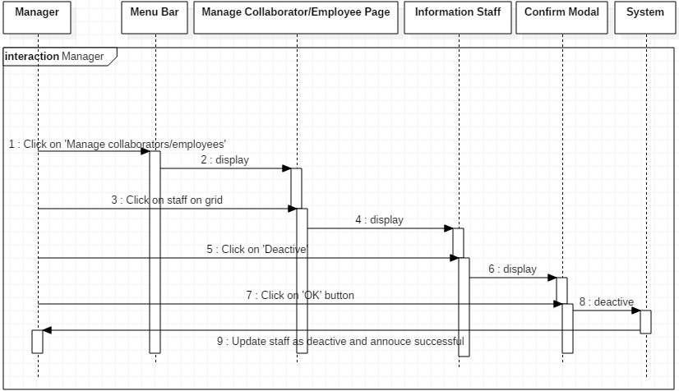

1. **Edit staff information**

|  |  |  |
| --- | --- | --- |
| **Author** | Nguyen Viet Hung | |
| **Use Case Name** | Edit staff information | |
| **Actors** | Manager, Administrator | |
| **Description** | Actor can edit information of staffs. | |
| **Requirements** | System must provide Information Staff Page. | |
| **Pre-conditions** | Actor must log in as Manager or Administrator. | |
| **Post-conditions** | Success: Edit staff information.  Fail: Show Error Page. | |
| **Basic flow** | Actor Actions:  1. Actor clicks on ‘Edit information’ button on Information Staff page.  [Alternative 1]  3. Actor inputs value and click ‘Update’ button. [Alternative 1] | System Responses:  2. System redirects to Edit Staff page:  - First name (text field)  - Last name (text field)  - Phone number (number)  - Email (text field)  - Date of birth (datetime)  - Address (text field)  - Gender (radio button)  - Working categories (checkbox)  (All fields are required)  - ‘Update’ button  - ‘Cancel’ button  4. System checks value in input fields.  [Exception 1]  5. System updates staff in server.  6. System annouces successful. |
| **Alternative flow** | Actor actions:  [Alternative 1]  1. Actor clicks ‘Home’ button | System Responses:  2. System returns to Home page. |
| **Exception** | Actor Actions:  [Exception 1]  1. Actor leaves first name blank.  2. Actor leaves last name blank.  7. Actor leaves phone number blank.  8. Actor leaves email blank.  9. Actor leaves date of birth blank.  10. Actor leaves address blank.  11. Actor doesn’t choose gender.  12. Actor doesn’t choose working categories. | System Responses:  System displays message to Actor :  - ‘First name required’.  - ‘Last name required’.  - ‘Phone number required’.  - ‘Email required’.  - ‘Date of birth required’.  - ‘Address required’.  - ‘Gender required’.  - ‘Working categories required’. |

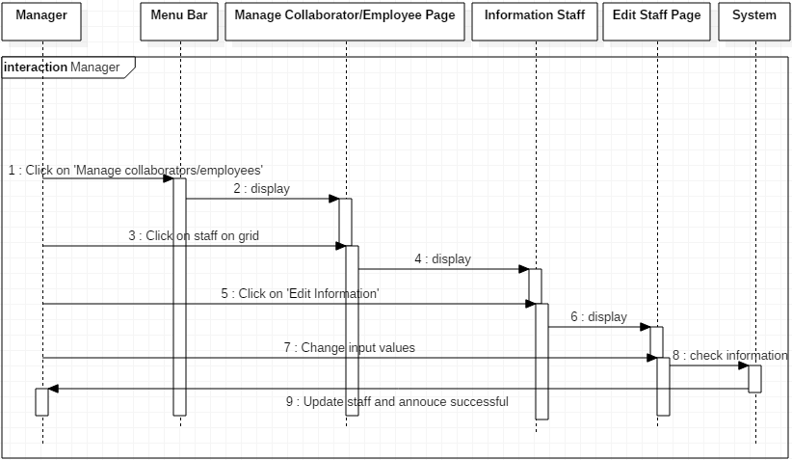

1. **Create new staff**

|  |  |  |
| --- | --- | --- |
| **Author** | Nguyen Viet Hung | |
| **Use Case Name** | Create new staff | |
| **Actors** | Manager, Administrator | |
| **Description** | Actor can create new staff. | |
| **Requirements** | System must provide Manage Employee page and Manage Collaborator page with grid of staffs and ‘Create new staff’ button. | |
| **Pre-conditions** | Actor must log in as Manager or Administrator. | |
| **Post-conditions** | Success: Create new staff.  Fail: Show Error Page. | |
| **Basic flow** | Actor Actions:  1. Actor clicks on ‘Create new staff’ button on Manage Employee page or Manage Collaborator page.  [Alternative 1]  3. Actor inputs value and click ‘Create new staff’ button. [Alternative 1] [Alternative 2] | System Responses:  2. System redirects to Create Staff page:  - First name (text field)  - Last name (text field)  - Username (text field)  - Phone number (number)  - Email (text field)  - Date of birth (datetime)  - Address (text field)  - Gender (radio button)  - Working categories (checkbox)  - Role (combobox)  (All fields are required)  - ‘Create new staff’ button  - ‘Cancel’ button  4. System checks value in input fields.  [Exception 1]  5. System inserts new staff in server.  6. System annouces successful. |
| **Alternative flow** | Actor actions:  [Alternative 1]  1. Actor clicks ‘Home’ button  [Alternative 2]  3. Actor clicks ‘Cancel’ button | System Responses:  2. System returns to Home page.  4. System returns to previous page. |
| **Exception** | Actor Actions:  [Exception 1]  1. Actor leaves first name blank.  2. Actor leaves last name blank.  3. Actor leaves username blank.  4. Username is existed.  7. Actor leaves phone number blank.  8. Actor leaves email blank.  9. Actor leaves date of birth blank.  10. Actor leaves address blank.  11. Actor doesn’t choose gender.  12. Actor doesn’t choose working categories.  13. Actor doesn’t choose role. | System Responses:  System displays message to Actor :  - ‘First name required’.  - ‘Last name required’.  - ‘Username required’.  - ‘Username existed’.  - ‘Phone number required’.  - ‘Email required’.  - ‘Date of birth required’.  - ‘Address required’.  - ‘Gender required’.  - ‘Working categories required’.  - ‘Role required’. |

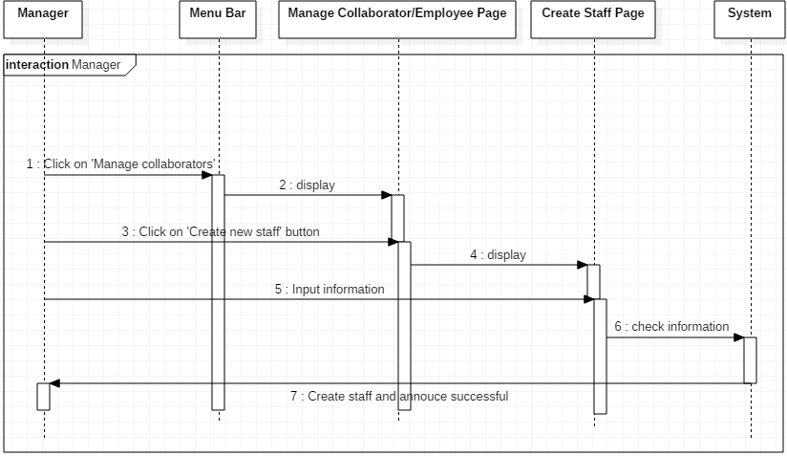

# Entity Relationship Diagram (ERD)

1. ***.Conceptual***

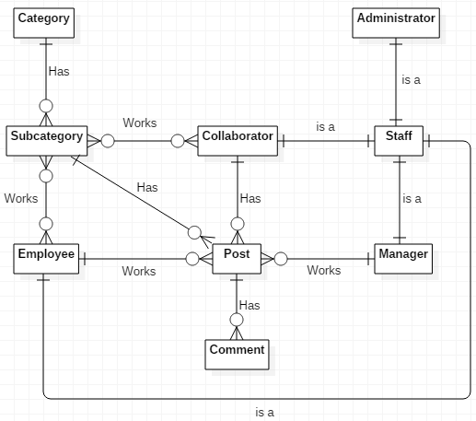

1. ***.Table***
2. **Staff**

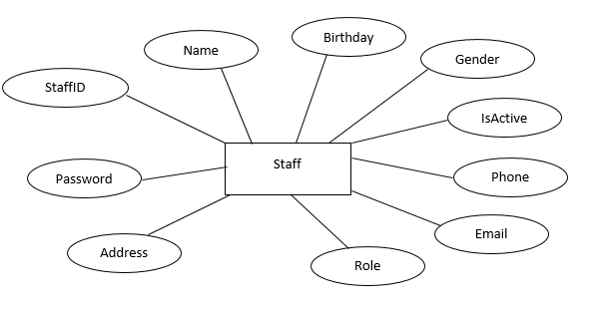

1. **Article**

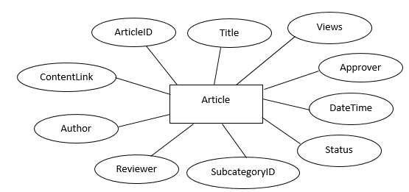

1. **Comment**

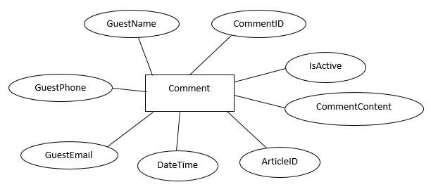

1. **Category**

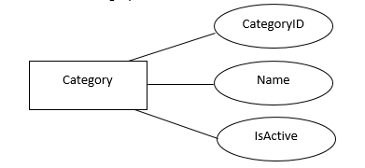

1. **Subcategory**

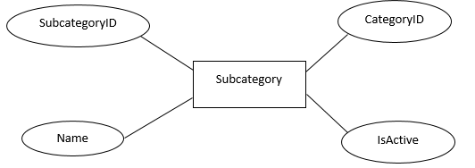

**REVIEW 3**

# Database Relationship Diagram

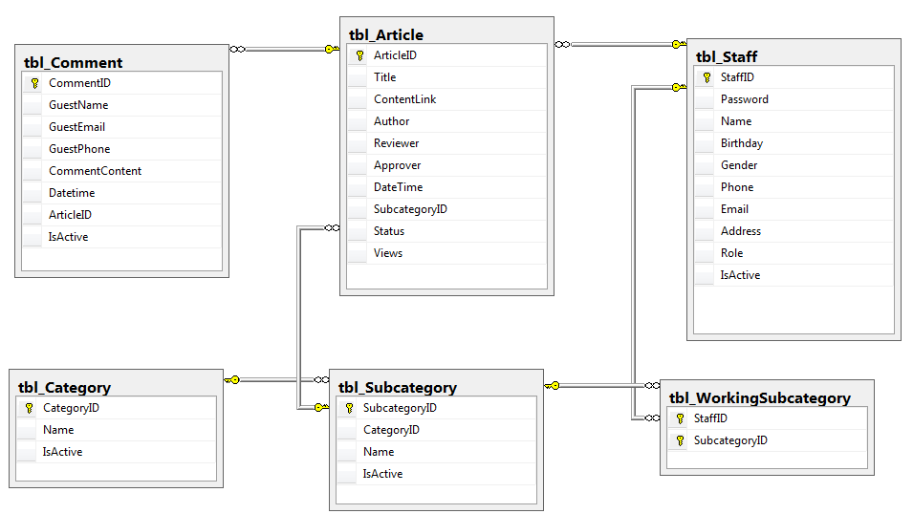

# Database Relationship Diagram

## ***Staff***